7.2.15 Editors - 3D View - Tool Shelf - Grease Pencil - Vertex Paint Mode
Tool Shelf - Grease Pencil - Vertex Paint Mode 1
Annotate tools 1
Select Tools 1
Footer 1
Draw 1
Blur 1
Average 2
Smear 2
Replace 2

Tool Shelf - Grease Pencil - Vertex Paint Mode
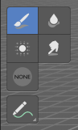
In Sculpt Mode you will mainly find brushes in the tool shelf.

Annotate tools
The annotate tools at the end of the list are explained in the chapter 7.1.1 Editors - 3D View - Tool Shelf - Object Mode. We won't cover this tools again here.
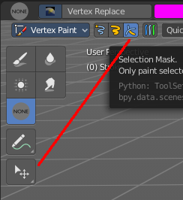

Select Tools
When you activate one of the mask modes then the select tool group appears. It is explained in the chapter 7.1.1 Editors - 3D View - Tool Shelf - Object Mode. We won't cover this tools again here.

Footer
When you use a brush then you will see some further informations to the brush.

Draw
Paint vertices.

Blur
Blur the color.

Average
Blends the color under the brush.

Smear
Smear the colors.

Replace
Replaces the vertex color under the mouse with the current color.

